**Linux Concept**

**OS (Operating System)**

-OS is an **interface between** Human and Machine

Kernal is the Heart of Operating System

Kernal perform two things that is Resource Allocation and Resource Negotiation

In Linus we have only File and Directory

1. We can have files inside Directory but directory cannot be inside the files.

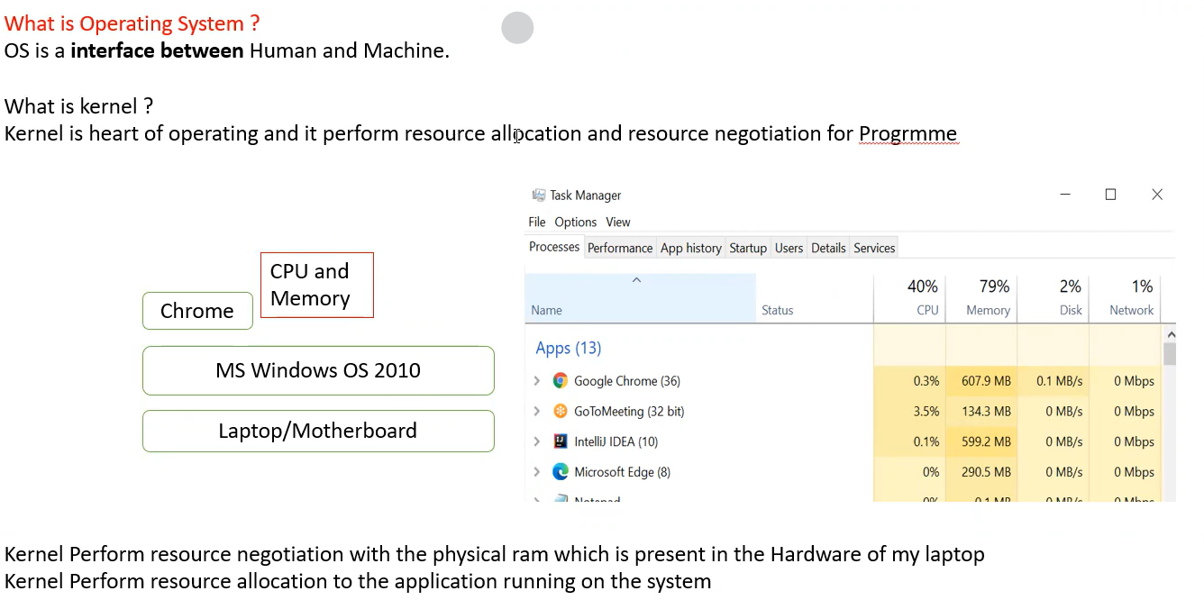

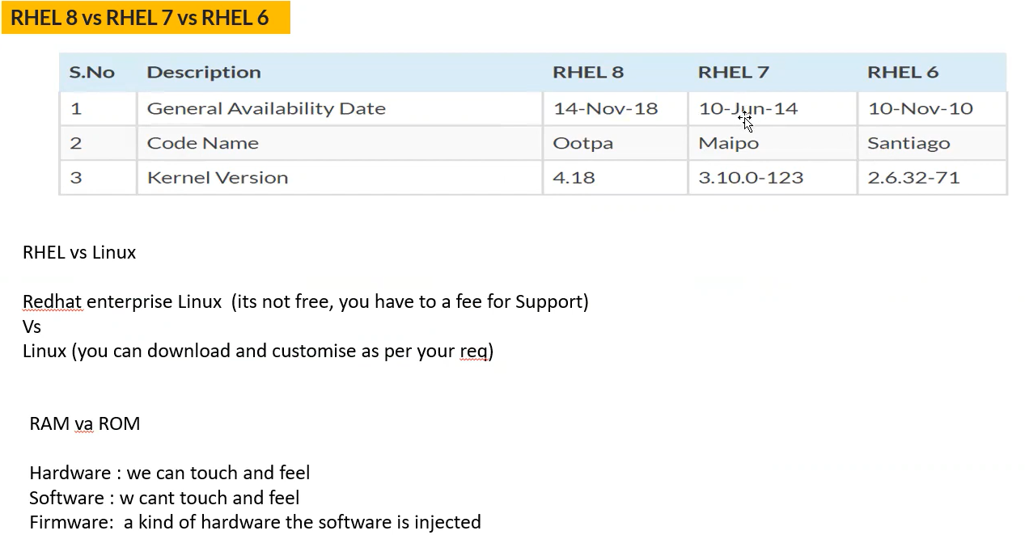

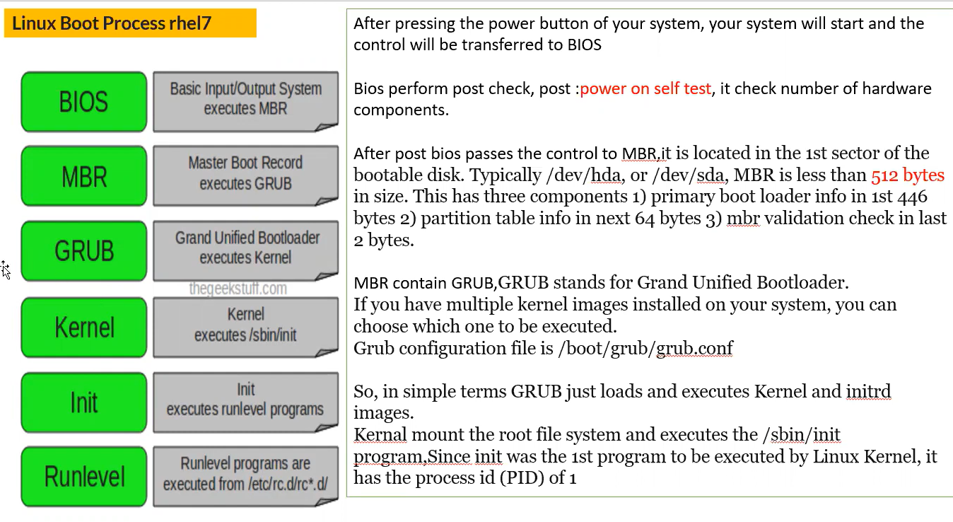

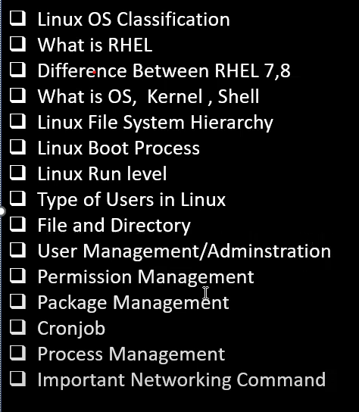



Sever

Operating System

Client



Windows

Mac

Linux

Windows

Unix

Linux



below is the diagram

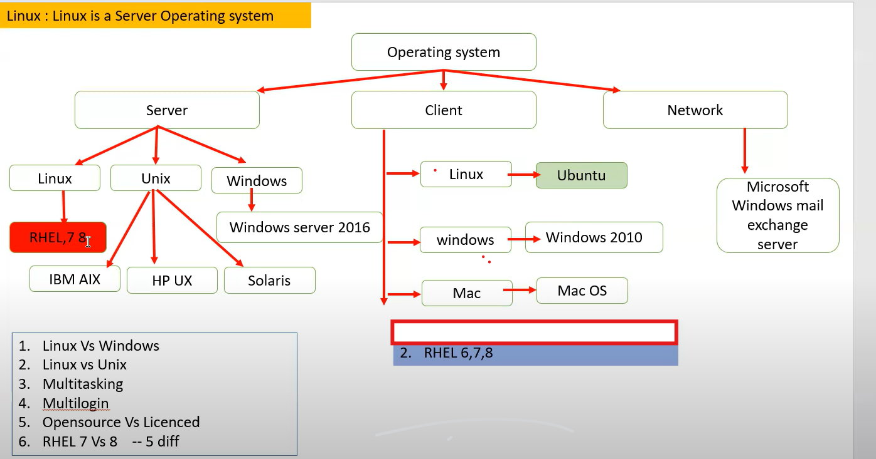

**Server side Linus - RedHat Enterprise Linux**

|  |  |
| --- | --- |
| Server OS | Client OS |
| Server OS which is used to run critical application ex: BSE, Nifty, New York Stock Exchange, Jio Billing System |  |

Under AWS we are calling Servers as **Instance**

How to create a Instand/Server on AWS on below ss

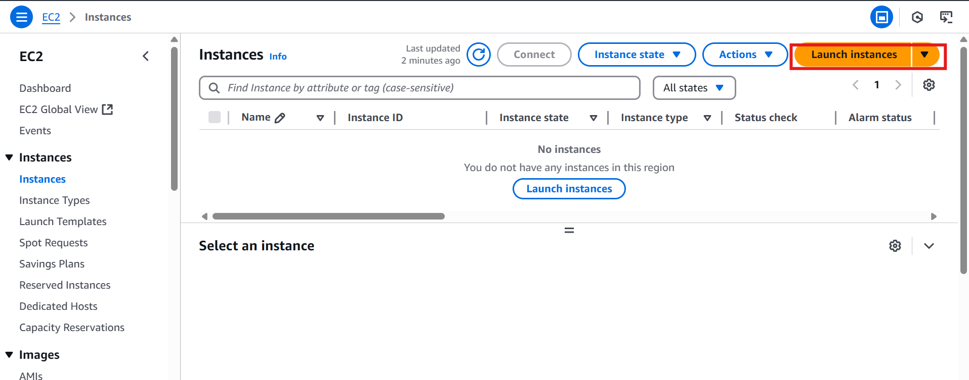

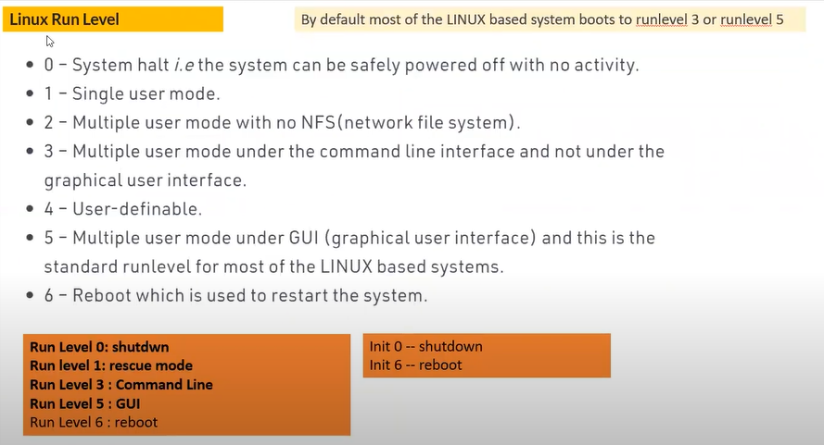

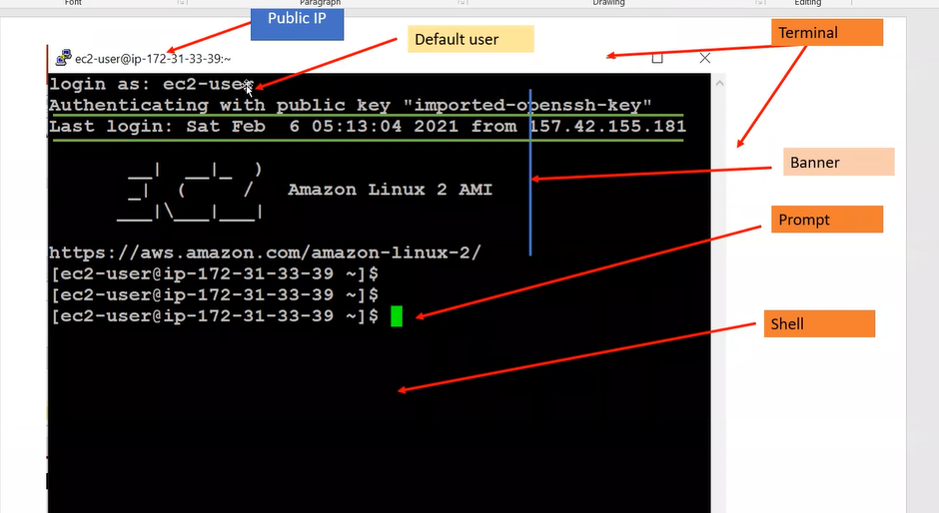

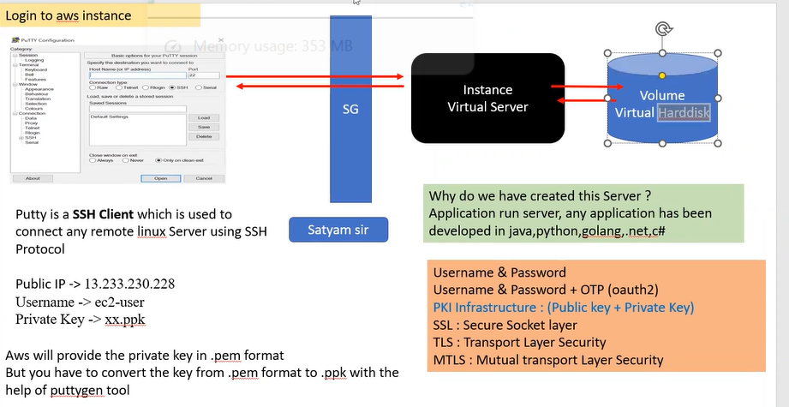

Linux command

**uname -a**

Above used for **linux os specification**



**free -m**

used for check the **RAM**

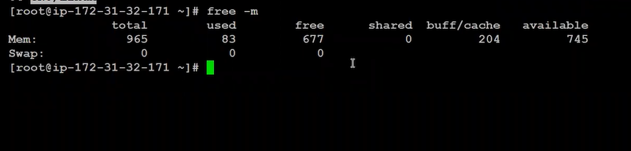

**cat /proc/cpuinfo**

used to check the processor infor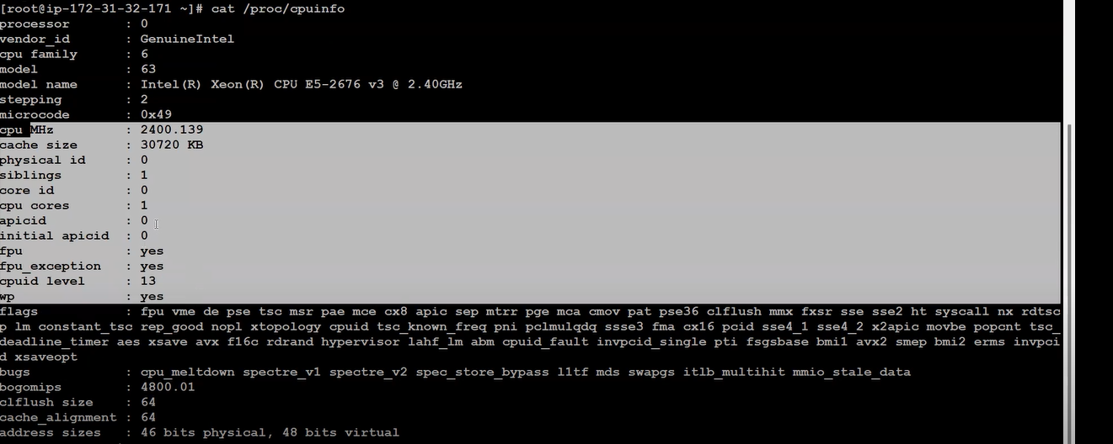

**lsblk**

To find how many hard disk

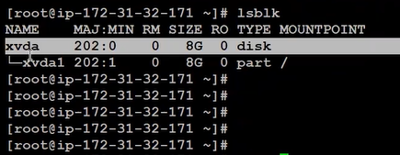

**df -h**

**use of hard disk**

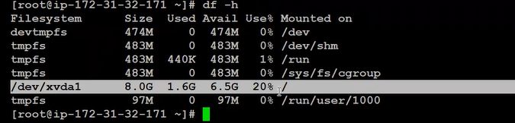

**cat /etc/os-release**

used to know which operating system we have

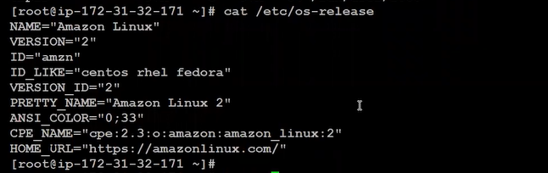

**history**

To identify which all command has been run on linux

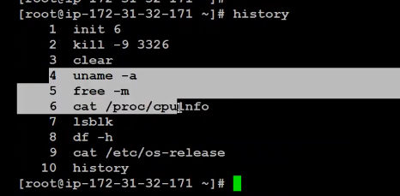

**top**

Used for to like task manager of linux

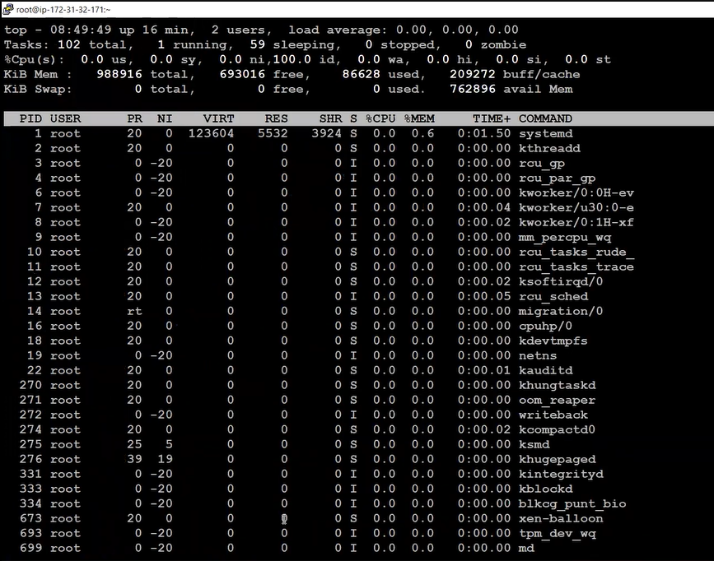

**uname -r**

it shows Kernal version



**uptime**

**it will show since from when linux server up and running how many uses login**



**w**

**to identify the how many user login to our system or server from which all location**

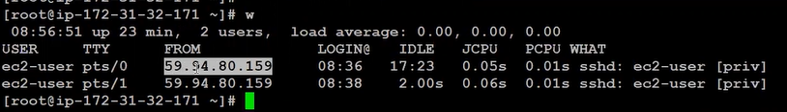

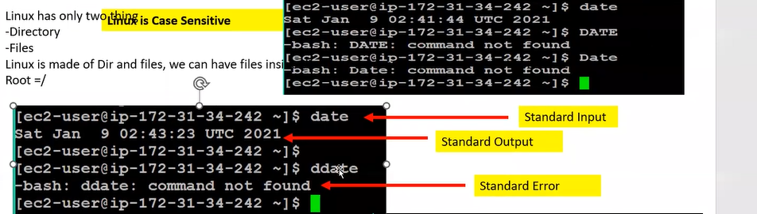

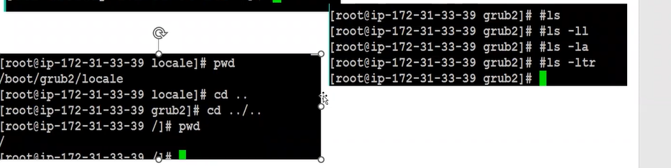

**cd**

**ls -ltr**

**ls -ltr Useful to check which files were modified earliest.**

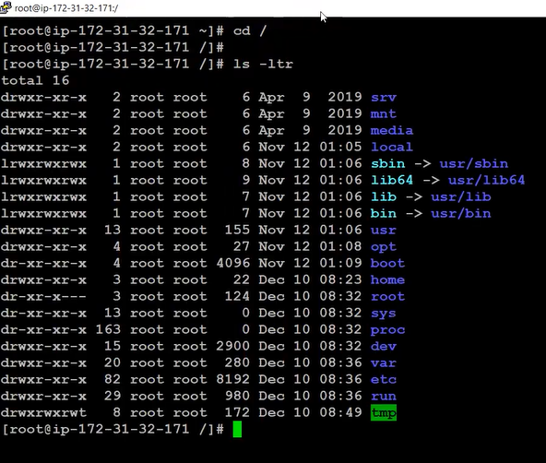

**pwd**

is used to **P**resent **W**orking **D**irectory or current location of directory

**cd boot**

it used to change the directory and go under boot directory

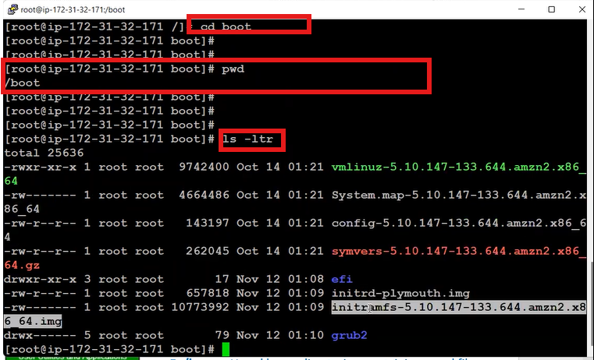

**Note:** directory means folder for understanding

In Directory there can be file but, in the file, there cannot be a Directory

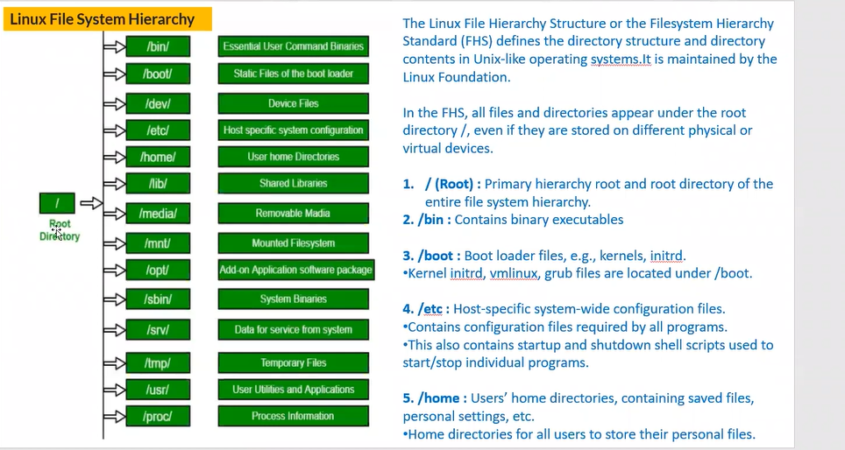

**cd..**

to come out of the directory/ to go back to the previous directory

How to identify which are files and which are directory below is the ss highlighted

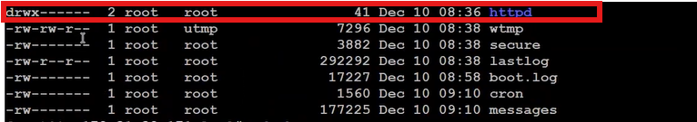

Linking file having **l** as below ss highlighted

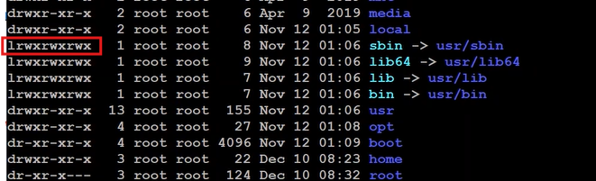

Listing command

**ls** => list

**ls -ll** => list long list

**ls -la** => it will show hidden files of the Directory

**ls -ltr** => List Time Recursive order

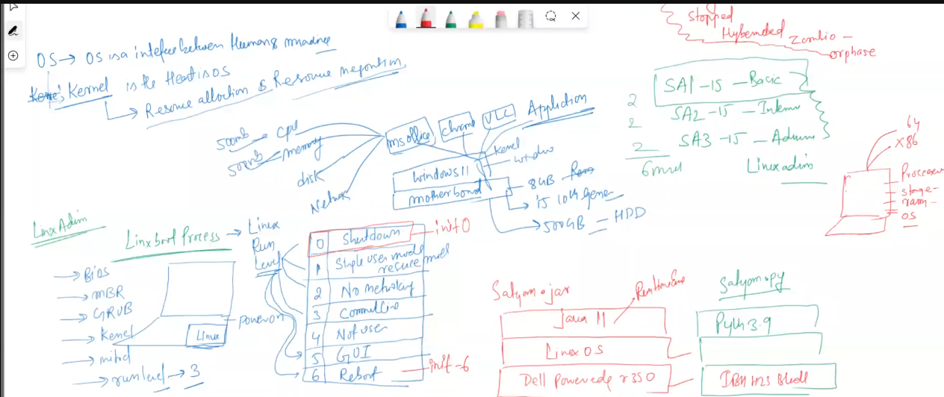

**Kernal**

Kernal will take the input and output in Binary format

**Shell**

From: - English literature/language will be sent to shell and shell will convert it into binary format,

From: - Binary format will be sent to shell and shell will convert it into English Language

English Language

Shell

Binary

Kernal

Default shell of Linux

* **/bin/bash**

What is the command to know the Default Shell of Linux

* **echo $SHELL**

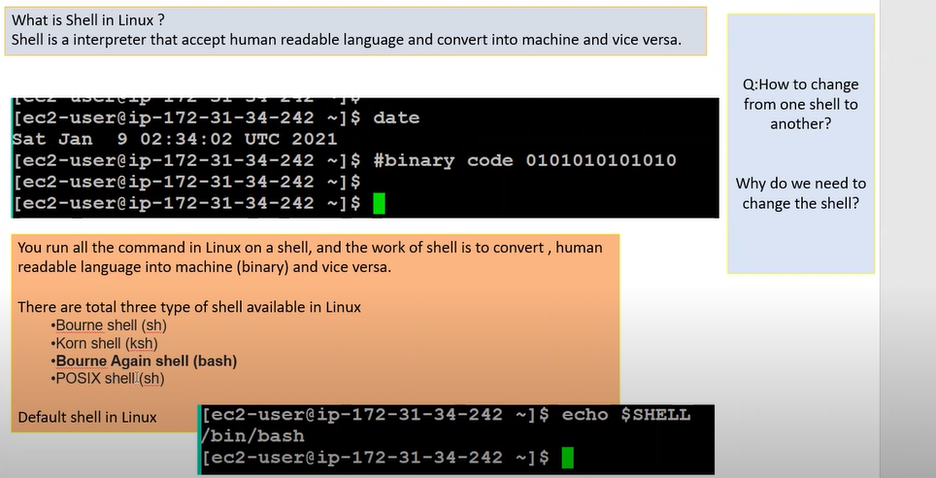

**init 6**

To restart the

**kill -9 3326**

to kill any process kill -9 process ID 3326

**clear**

**cal**

**cal 2032**

**cal 2026**

it will show the calender

**date**

**touch mobile.txt**

touch is a command which is used to create an empty file or folder

**cat**

**cat mobile.txt**

**cat > phone.txt**

**hello I am good**

**cat phone.txt**

cat is a command which used to open a file.

cat is a command which is used to create a file

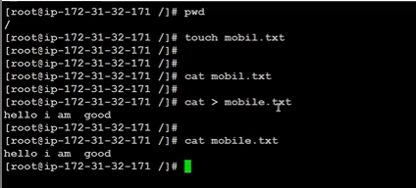

Relative Path

Absolute Path

Path

Complete Address is Absolute Path below ss

**Any address starting from root is called as Absolute Path**

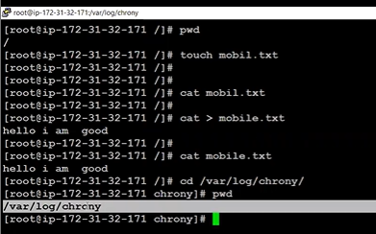

**Absolute path example**

**cd /var/log**

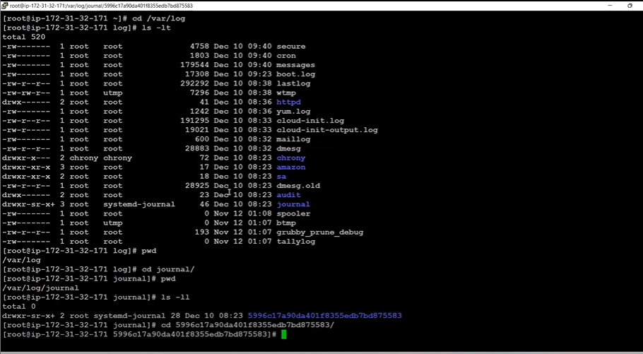

**Relative Path Example**

Interim and relative path is called as Relative Path

Using **cd ../../httpd** commandas per below ss

